

**Department of Computer Science and Engineering**

**21st Batch**

**Lab Report 4**

|  |  |
| --- | --- |
| Course title | : Digital Signal Processing Lab |
| Course Code | : CSE-414 |

|  |  |  |  |
| --- | --- | --- | --- |
| **Submitted By** | | **Submitted To** | |
|  |  |  |  |
| Name | : Md. Mahfujur Rahman | Name | : Salma Akter Lima |
| ID | : 192311014 | Designation | : Lecturer(Provisional),  Varendra University,  Rajshahi |
| Section | : A |  |
| Semester | : 10th |  |
| Batch | : 21st | Name | : Sumaiya Tasnim |
|  |  | Designation | : Lecturer(Provisional),  Varendra University,  Rajshahi |
|  |  |  |

------------

|  |  |
| --- | --- |
| Signature | Submission date: 25-08-2022 |
|  |  |

**Problem Statement:** Create a basic data set as a CSV file then perform EDA analysis on that data set.

**Theory:** In [statistics](https://en.wikipedia.org/wiki/Statistics), exploratory data analysis is an approach of [analyzing](https://en.wikipedia.org/wiki/Data_analysis) [data sets](https://en.wikipedia.org/wiki/Data_set) to summarize their main characteristics, often using [statistical graphics](https://en.wikipedia.org/wiki/Statistical_graphics) and other [data visualization](https://en.wikipedia.org/wiki/Data_visualization) methods. A [statistical model](https://en.wikipedia.org/wiki/Statistical_model) can be used or not, but primarily EDA is for seeing what the data can tell us beyond the formal modeling and thereby contrasts traditional hypothesis testing.

Exploratory data analysis has been promoted by [John Tukey](https://en.wikipedia.org/wiki/John_Tukey) since 1970 to encourage statisticians to explore the data, and possibly formulate hypotheses that could lead to new data collection and experiments. EDA is different from [initial data analysis (IDA)](https://en.wikipedia.org/wiki/Data_analysis#Initial_data_analysis), which focuses more narrowly on checking assumptions required for model fitting and hypothesis testing, and handling missing values and making transformations of variables as needed. EDA encompasses IDA.

Exploratory data analysis (EDA) is used by data scientists to analyze and investigate data sets and summarize their main characteristics, often employing data visualization methods. It helps determine how best to manipulate data sources to get the answers you need, making it easier for data scientists to discover patterns, spot anomalies, test a hypothesis, or check assumptions.

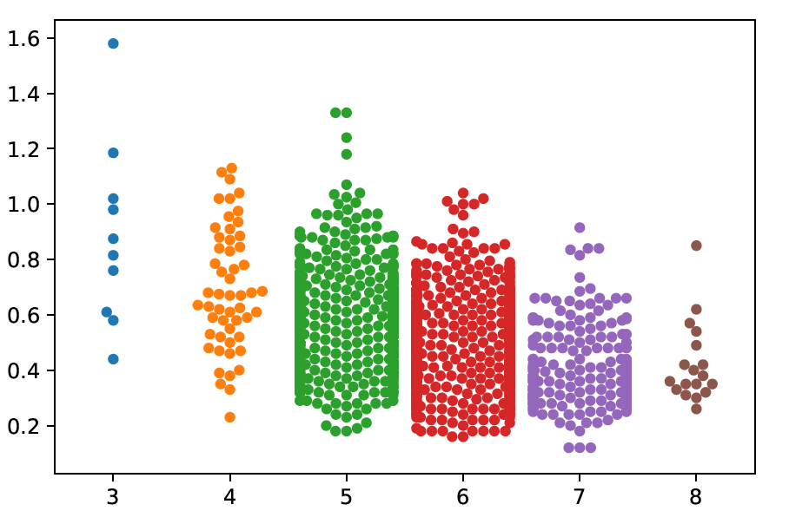

**CODE:**

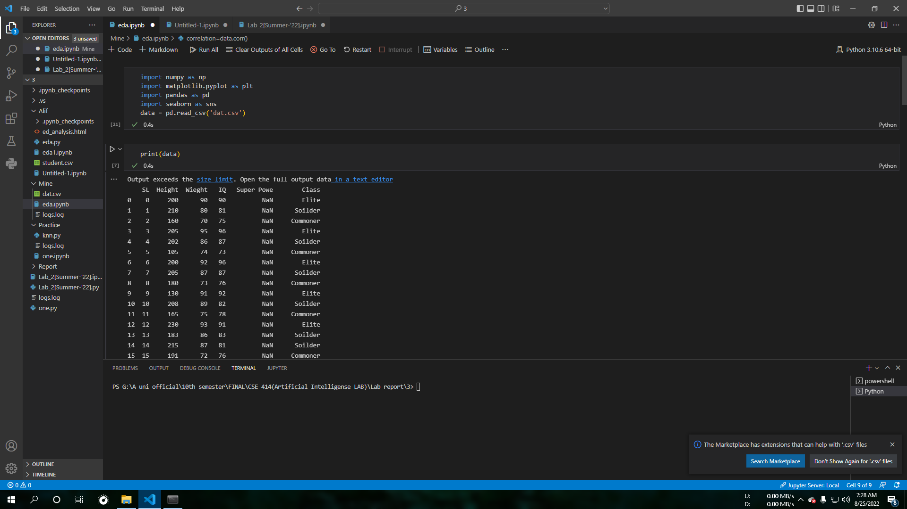

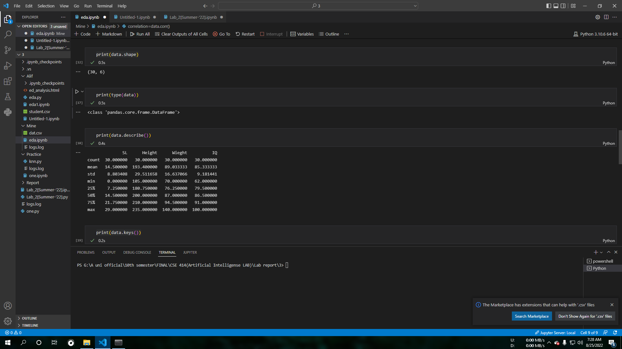

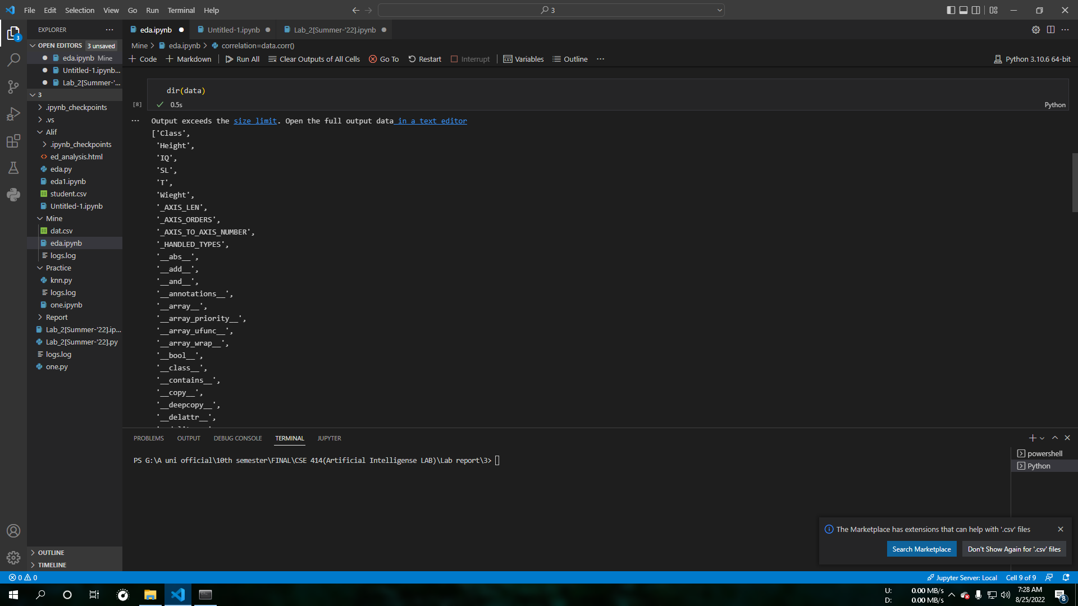



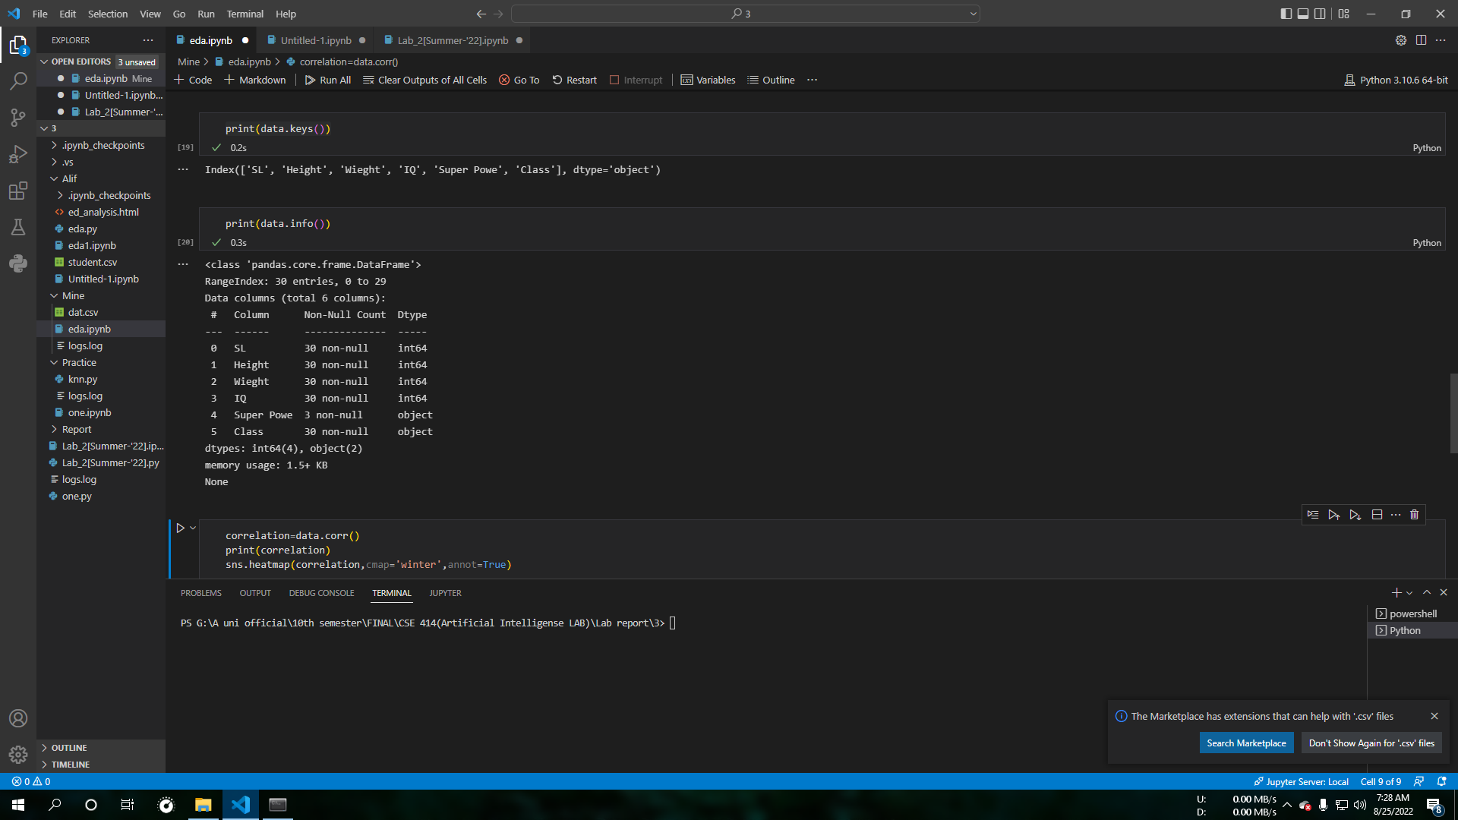

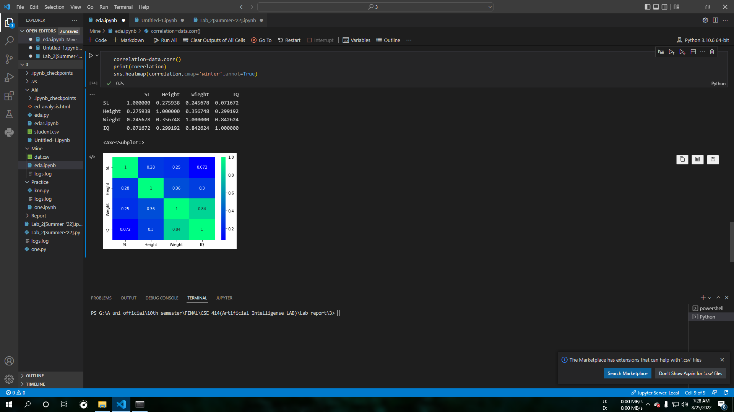

**Conclusion :** By simply using the pandas library we can import our csv file as our data sets then perform different operation on it . by using the seaborn library we can also perform Graphical EDA analysis upon the data set.